CURRENCY CONVERTER WITH REAL-TIME EXCHANGE RATE

JOHN BITRUS
(st/cs/nd/24/137)

ABDULLAHI SALISU
(st/cs/nd/24/179)

ABDULKADIR ADAMU
(st/cs/nd/24/224)

A SEMINAR PRESENTED TO THE DEPARTMENT OF COMPUTER SCIENCE, SCHOOL OF SCIENCE AND TECHNOLOGY, FEDERAL POLYTECHNIC MUBI, ADAMAWA STATE, NIGERIA

JULY, 2026
CURRENCY CONVERTER WITH REAL-TIME EXCHANGE RATE

JOHN BITRUS
(st/cs/nd/24/137)

ABDULLAHI SALISU
(st/cs/nd/24/179)

ABDULKADIR ADAMU
(st/cs/nd/24/224)

A SEMINAR PRESENTED TO THE DEPARTMENT OF COMPUTER SCIENCE, SCHOOL OF SCIENCE AND TECHNOLOGY, FEDERAL POLYTECHNIC MUBI, ADAMAWA STATE, NIGERIA

IN PARTIAL FULFILLMENT OF THE REQUIREMENTS FOR THE AWARD OF NATIONAL DIPLOMA (ND) IN COMPUTER SCIENCE

JULY, 2026

Abstract
Currency conversion has become an essential component of international trade, tourism, e-commerce, online banking, and global financial transactions. The increasing globalization of business activities has created a growing demand for systems capable of providing accurate and real-time foreign exchange rates. A real-time currency converter is a software application that retrieves current exchange rate data from financial service providers through Application Programming Interfaces (APIs) and instantly converts one currency into another. This seminar examines the concept of currency converters with real-time exchange rates, their architecture, technologies, benefits, challenges, applications, and future prospects. The study also discusses the role of cloud computing, RESTful APIs, artificial intelligence, and blockchain technology in enhancing the performance and reliability of modern currency conversion systems. The seminar concludes that real-time currency converters have become indispensable tools in today's digital economy by providing accurate, efficient, and transparent currency exchange services for individuals and organizations worldwide.
Keywords: Currency Converter, Exchange Rate, Real-Time API, Foreign Exchange, FinTech, REST API, Web Application, Cloud Computing.

Introduction
The rapid advancement of globalization, digital transformation, and financial technology (FinTech) has fundamentally changed the way individuals, businesses, and governments conduct financial transactions across international borders. The growth of international trade, cross-border investments, online shopping, tourism, foreign remittances, and digital payment systems has significantly increased the need for accurate and efficient currency conversion services. As economic activities become increasingly interconnected, the ability to access reliable and up-to-date exchange rate information has become essential for informed financial decision-making. According to International Monetary Fund (2024), the increasing integration of global financial markets has heightened the importance of timely exchange rate information in facilitating international commerce, maintaining financial stability, and supporting economic growth. Consequently, real-time currency conversion systems have become indispensable tools in today's digital economy (Dwivedi et al., 2023).
A currency converter is a software application designed to convert the value of one country's currency into another using prevailing exchange rates. Unlike traditional currency converters that rely on manually updated exchange tables or fixed exchange rates published periodically by financial institutions, modern currency converters automatically retrieve current exchange rate data from online financial service providers through secure Application Programming Interfaces (APIs). Sharma and Gupta (2025) explained that integrating real-time APIs into currency conversion applications enables continuous synchronization with foreign exchange markets, thereby providing users with accurate and reliable conversion results.
Similarly, Singh and Verma (2024) observed that API-driven currency converters have significantly improved the speed, efficiency, and accuracy of financial transactions by eliminating delays associated with manual exchange rate updates. The foreign exchange (Forex) market is recognized as the largest and most liquid financial market globally, recording daily trading volumes exceeding US$7.5 trillion. Exchange rates fluctuate continuously due to numerous macroeconomic and geopolitical factors, including inflation, interest rates, monetary policies, international trade balances, political stability, market demand and supply, and global economic events.
Literature Review
According to Borio et al. (2022) of the Bank for International Settlements, these continuous fluctuations require financial systems capable of providing instantaneous exchange rate information to ensure transparency and accuracy in international financial transactions. Eichengreen (2023) emphasized that access to real-time exchange rate information enhances market efficiency by reducing information asymmetry and improving financial decision-making among businesses, investors, and consumers. The emergence of Financial Technology (FinTech) has accelerated the development of intelligent currency converter applications capable of operating seamlessly across web platforms, mobile devices, banking systems, enterprise resource planning (ERP) software, and e-commerce websites.
Gomber et al. (2022) noted that FinTech innovations have transformed conventional financial services through automation, cloud computing, artificial intelligence, and secure digital infrastructures. These technologies enable currency converter applications to retrieve, process, and display exchange rate information within seconds while supporting multiple currencies simultaneously. In addition, Kou et al. (2023) argued that cloud-based financial applications have significantly enhanced the scalability, availability, and reliability of real-time financial services, including online currency conversion systems.
Modern currency converter applications incorporate several advanced technologies to ensure speed, security, and reliability. These technologies include Representational State Transfer (REST) APIs, JavaScript Object Notation (JSON), cloud computing, Secure Socket Layer (SSL) encryption, database management systems, and mobile computing platforms. According to Fielding (2022), RESTful web services provide an efficient architectural framework for communication between client applications and remote financial servers. Similarly, Richardson and Ruby (2023) maintained that REST APIs simplify data exchange between applications, making them suitable for financial systems that require real-time information retrieval. Furthermore, Fowler (2022) explained that JSON has become the preferred data interchange format for modern web applications because of its lightweight structure, readability, and compatibility with multiple programming languages.
Recent technological advancements in artificial intelligence (AI), machine learning, blockchain technology, and big data analytics have further enhanced the capabilities of real-time currency converter systems. Dwivedi et al. (2023) observed that artificial intelligence has improved financial applications by enabling predictive analytics, intelligent decision support, fraud detection, and exchange rate forecasting. Likewise, Casino et al. (2022) reported that blockchain technology provides greater transparency, immutability, and security for financial transactions, thereby reducing fraud and enhancing trust in digital financial ecosystems. These emerging technologies are expected to play increasingly important roles in the future development of intelligent financial applications.
Despite the numerous advantages of real-time currency converters, several challenges continue to affect their performance and reliability. These include dependence on stable internet connectivity, fluctuations in exchange rates, API usage limitations, cybersecurity threats, server downtime, network latency, and subscription costs associated with premium financial data providers. According to NIST (2024), financial web applications remain primary targets for cyberattacks, making the implementation of robust security measures essential for protecting sensitive financial information. Additionally, the World Bank (2024) emphasized that disparities in digital infrastructure across countries continue to limit equitable access to real-time financial technologies, particularly in developing economies.
Concept of Currency
According to the International Monetary Fund (2024), a currency represents legal tender accepted for domestic and international financial transactions and is influenced by macroeconomic conditions, monetary policies, and foreign exchange markets. Currency refers to the officially recognized medium of exchange issued and regulated by a country's central monetary authority for buying goods, paying for services, and settling financial obligations. It serves as the foundation of every economy by facilitating trade and commerce between individuals, organizations, and governments. Examples of major world currencies include:
- United States Dollar (USD)
- Euro (EUR)
- British Pound Sterling (GBP)
- Nigerian Naira (NGN)
- Japanese Yen (JPY)
- Chinese Yuan (CNY)
- Canadian Dollar (CAD)
- Australian Dollar (AUD)
The value of a currency relative to another is determined through the foreign exchange market, where exchange rates fluctuate continuously based on supply and demand.
Concept of Currency Converter
A currency converter is a computerized application designed to convert monetary values from one currency into another using current or historical exchange rates. According to recent FinTech studies, modern currency converters automatically retrieve live exchange rate information from trusted financial data providers through APIs, eliminating the inaccuracies associated with manually maintained conversion tables (Kou et al., 2023). A standard currency converter performs the following operations:
- Accepts an amount from the user.
- Accepts the source currency.
- Accepts the destination currency.
- Retrieves the latest exchange rate.
- Calculates the converted value.
- Displays the result instantly.
Real-Time Exchange Rate
A real-time exchange rate refers to the current market value of one currency relative to another at a particular moment. Unlike static exchange rates stored in databases, real-time exchange rates are continuously updated from financial markets and banking institutions. These exchange rates are obtained from:
- International foreign exchange markets
- Commercial banks
- Central banks
- Financial institutions
- Foreign exchange data providers
Real-time exchange rate systems ensure that users receive the most recent conversion values, thereby improving the accuracy of international transactions.
Features of a Currency Converter with Real-Time Exchange Rate
In a seminar or project report, features describe what the system can do, while components describe the major parts that make those features possible. A modern currency converter with real-time exchange rates is typically built around a user interface, a processing engine, live exchange-rate services, data storage, security mechanisms, and cloud infrastructure. Recent FinTech research emphasizes that API-driven financial applications depend on these integrated components to deliver accurate, timely, and secure currency conversion services (Gomber et al., 2022
Key Features of the System
Real-Time Exchange Rate Retrieval: The converter automatically fetches the latest exchange rates from online financial APIs instead of relying on manually entered values. This ensures that conversion results reflect current market conditions. Sharma and Gupta (2025) noted that continuous API synchronization significantly improves conversion accuracy in financial applications.
Instant Currency Conversion: Users enter an amount, choose a source currency and a target currency, and receive the converted value immediately. This minimizes delays in online shopping, travel planning, and international payments.
Multi-Currency Support: Modern converters support dozens or hundreds of global currencies, including fiat currencies such as USD, EUR, GBP, NGN, JPY, and CNY. Many platforms also support regional and digital currencies.
Historical Exchange Rate Lookup: Users can view previous exchange rates for financial analysis, accounting, budgeting, and research purposes. Historical data helps organizations compare currency performance over time.
Responsive Web and Mobile Access: The system is designed to work on desktops, tablets, and smartphones. Responsive interfaces improve accessibility for travelers, students, and business users.
Secure Data Transmission: Financial data is protected using HTTPS, SSL/TLS encryption, API authentication, and access controls. NIST (2024) recommends these mechanisms for securing financial web applications.
Rate Caching and Offline Support: Recently retrieved exchange rates can be cached locally to reduce API calls and maintain limited functionality during temporary network interruptions.
Exchange Rate Alerts and Notifications: Some systems allow users to set target exchange rates and receive notifications when the market reaches those values, supporting investment and trading decisions.
Major Components of the System
User Interface (Frontend): This is the visible part of the application where users enter amounts and select currencies. Typical technologies: HTML5, CSS3, Bootstrap, JavaScript, React, or Vue.js.
Application Server (Backend): The backend processes requests, communicates with APIs, performs calculations, and returns results to the frontend. Common technologies: PHP, Node.js, Python, Java, Laravel, or Express.js.
Exchange Rate API Service: This component provides live market data. The backend sends requests to the API and receives current exchange rates in JSON format. Examples: ExchangeRate API, Fixer API, Open Exchange Rates, Frankfurter API. Fielding (2022) explained that RESTful APIs are well suited for real-time financial data exchange because they are lightweight and scalable.
Database Management System: The database stores conversion history, user preferences, cached rates, and audit logs. Common databases: MySQL, PostgreSQL, MongoDB.
Conversion Engine: This module performs the actual currency calculation using the retrieved exchange rate.
Core logic
Converted Amount = Amount × Exchange Rate
Example
₦10,000 × 0.00063 = $6.30
Security Layer: Security protects financial data and API credentials.
Security mechanism | Purpose
HTTPS/SSL | Encrypts communication
API keys | Authenticates requests
Access control | Restricts unauthorized use
Rate limiting | Prevents abuse
Scheduler and Update Service: A background service periodically refreshes exchange rates and updates cached records without requiring user action.
Cloud Infrastructure: Cloud platforms host the application, database, and API integrations, enabling scalability and high availability. Examples: AWS, Microsoft Azure, Google Cloud Platform. Kou et al. (2023) found that cloud deployment improves the reliability and scalability of financial applications.
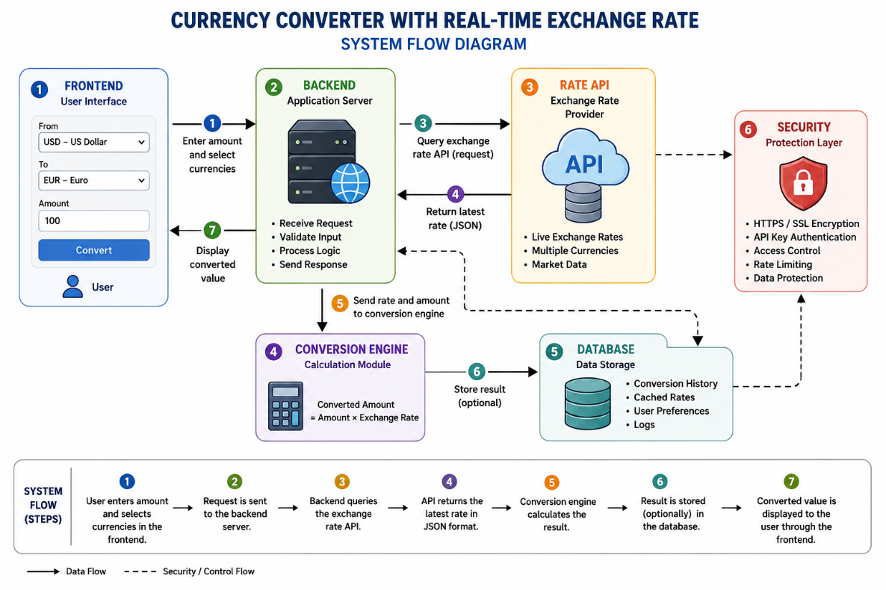
Figure 1: Components of Currency Converter (Kou et al., 2023)
Advantages of a Currency Converter with Real-Time Exchange Rate
- A real-time currency converter retrieves the latest exchange rates from reliable financial data providers, ensuring that users receive accurate and up-to-date conversion results. This minimizes errors associated with outdated or manually updated exchange rates.
- Businesses involved in import, export, and international trade can easily calculate the value of goods and services in different currencies, thereby improving pricing accuracy and financial planning.
- Customers purchasing products from international online stores can instantly determine the equivalent cost in their local currency, making purchasing decisions easier and more transparent.
- Unlike manual calculations, real-time currency converters provide instant results, reducing the time required to perform currency conversions and improving productivity.
- Real-time currency converters are available through websites and mobile applications, allowing users to perform conversions anytime and anywhere with an internet connection.
- Travelers can estimate expenses accurately before visiting another country by converting their local currency into the destination country's currency using current exchange rates.
- Automated calculations eliminate arithmetic mistakes that commonly occur during manual currency conversions.
Disadvantages of a Currency Converter with Real-Time Exchange Rate
- Since real-time exchange rates are retrieved from online servers, the application requires a stable internet connection. Poor or unavailable internet service may prevent the system from obtaining current exchange rates.
- Exchange rates fluctuate continuously due to economic, political, and market conditions. Consequently, the converted value may change within a short period, making it difficult to maintain consistent pricing.
- The performance of the currency converter depends on third-party exchange rate APIs. If the API provider experiences downtime or service interruptions, the application may fail to retrieve current exchange rates.

Conclusion
In conclusion, a Currency Converter with Real-Time Exchange Rate is an essential financial application that provides users with accurate, fast, and reliable currency conversion services by retrieving live exchange rate data from trusted financial APIs. The system plays a significant role in facilitating international trade, online shopping, tourism, banking, investment, and other cross-border financial activities. By integrating modern technologies such as RESTful APIs, cloud computing, secure communication protocols, and database management systems, the application ensures efficiency, accuracy, and ease of use. Despite challenges such as internet dependency, exchange rate volatility, API limitations, and cybersecurity concerns, the benefits of real-time currency converters far outweigh their limitations. As financial technology continues to evolve, real-time currency conversion systems are expected to become more intelligent, secure, and widely adopted, thereby contributing significantly to the growth of the global digital economy.
Recommendations
- Use reliable and reputable exchange rate API providers to ensure accurate and up-to-date currency data.
- Integrate historical exchange rate analysis and graphical trends to support financial planning and decision-making.
- Employ cloud computing technologies to improve system scalability, availability, and performance.
- Implement artificial intelligence techniques for exchange rate prediction and personalized financial insights.
- Conduct regular system maintenance and performance monitoring to ensure reliability and minimize downtime.
- Educate users on exchange rate fluctuations and encourage them to verify rates before completing significant financial transactions.

REFERENCES
Arslanalp, S., Eichengreen, B., & Simpson-Bell, C. (2022). The stealth erosion of dollar dominance: Active diversifiers and the rise of nontraditional reserve currencies. Journal of International Economics, 138, 103656.
Casino, F., Dasaklis, T. K., & Patsakis, C. (2022). Blockchain-based financial technologies: A systematic literature review. ACM Computing Surveys, 55(3), 1–36.
Dwivedi, Y. K., Hughes, L., Baabdullah, A. M., & Ribeiro-Navarrete, S. Wamba, S. F. (2023). So what if ChatGPT wrote it? Multidisciplinary perspectives on opportunities, challenges and implications of generative conversational AI for research, practice and policy. International Journal of Information Management, 71, 102642.
Eichengreen, B. (2024). International finance and geopolitics. Asian Economic Policy Review, 19(1), 84–100.
Fielding, R. T. (2022). Architectural styles and the design of network-based software architectures. University of California, Irvine.
Fowler, M. (2022). Patterns of enterprise application architecture (2nd ed.). Addison-Wesley.
Gomber, P., Koch, J.-A., & Siering, M. (2022). Digital finance and FinTech: Current research and future directions. Journal of Business Economics, 92(4), 575–603.
International Monetary Fund. (2024). External sector report: Chapter 2—International monetary system: Currencies in a changing world. https://www.imf.org
Kou, G., Akdeniz, O. Ö., Dinçer, H., & Yüksel, S. (2023). FinTech and cloud-based financial services: A systematic review. Financial Innovation, 9(1), 1–24.
National Institute of Standards and Technology. (2024). Guidelines for securing web applications and application programming interfaces (APIs). U.S. Department of Commerce.
Richardson, L., & Ruby, S. (2023). RESTful web APIs (Updated ed.). O'Reilly Media.
Sharma, R., & Gupta, A. (2025). Real-time API integration for currency conversion applications. International Journal of Financial Technology, 7(2), 44–58.
World Bank. (2024). Addressing exchange rate risk in infrastructure projects in emerging markets and developing economies. World Bank Group.

